Use-Case Realization Report (Design)
View Page

Issue <1.0>
Revision History
Date | Issue | Description | Author
29/11/09 | 1.0 | Initial Version | Rajendran Kumaraguru

Table of Contents
1. Brief Description 4
2. Flow of Events 4
2.1 Standard Flow 4
2.2 Exception Flow 4
3. Interaction Diagrams 5
3.1 Sequence Diagram for View Page 5
4. Participating Objects 5
5. Class Diagrams 6
5.1 Class Diagram for ViewPage 6
6. Derived Requirements 6

Use-Case Realization Report (Design)
View Page

Brief Description
Upon successful creation of Company, Site and Outline. Portal admin will be able to view the existing pages irrespective of company or subscription status.

Flow of Events

Standard Flow
- Portal Admin log into the system, and go to Page Admin Page.
- Click the view page to get the detail of particular page.
- Load the page details
- Get the page details
- Validate field validates the input values.
- Get page info will fetch the details from entity object.
- Page will be shown to portal admin

Exception Flow
- If the validation is failed then exception will be shown to portal admin
- If the requested page is not available in the system will throw the exception to portal admin

Interaction Diagrams

Sequence Diagram for View Page
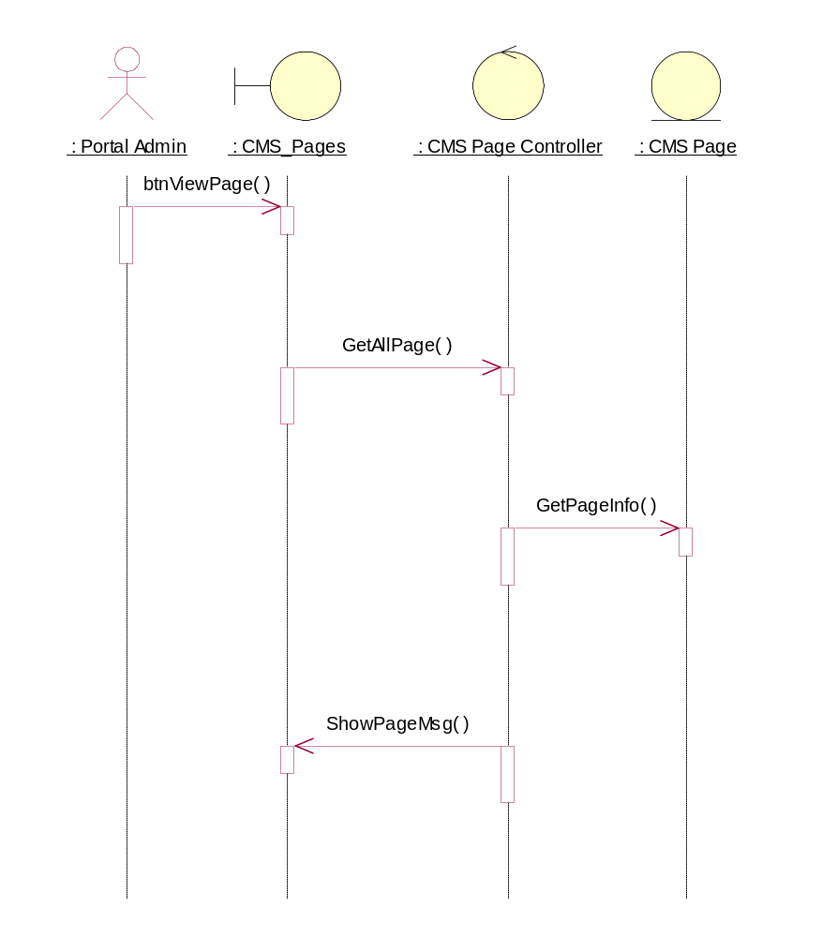

Participating Objects
: CMS Page

: CMS Page Controller

: CMS_Pages

: Portal Admin

Class Diagrams

Class Diagram for ViewPage
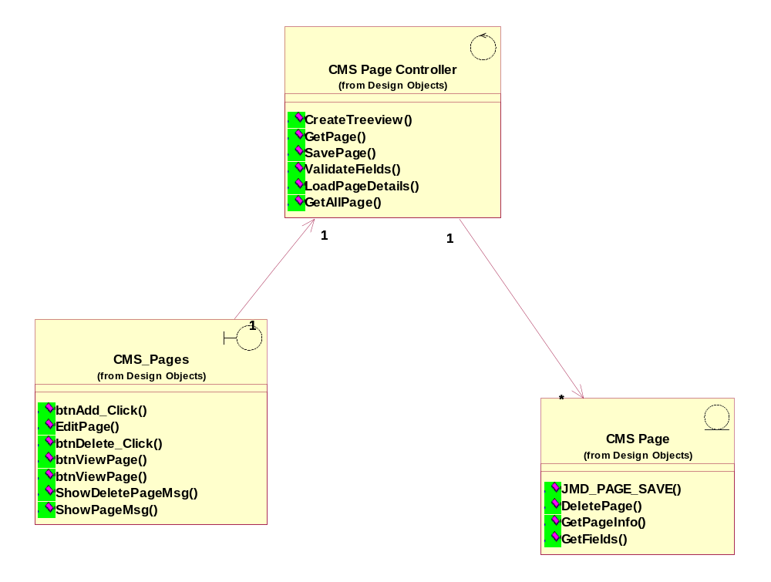

Derived Requirements
[enter the derived requirements here]

